Greetings in the most precious name of our Lord & Savior Jesus Christ,

MIRACLE RESTORATION REVIVAL
USA - INDIA

“Religion that God our Father accepts as pure and faultless is this; to look after orphans and widows in their distress and to keep oneself from being polluted by the world”. James 1:27.

We thank our dear Lord for giving us again an opportunity to feed the Yanadi Children of our village. The Yanadi community is one of the most downtrodden communities in our village. They are treated as untouchables. They do not have proper roofed houses, children beg in the streets, men and women earn money by doing some odd jobs, children & elders are addicted to alcohol. They believe in false culture & god’s. We are so happy to say that Miracle Restoration Revival is the only Ministry who are working for the welfare and development of Yandi community in our village. Some of our works are feeding the Yanadi children, preaching them the Gospel of Jesus Christ, providing clothes, helping the entire Yanadi community with food during cyclones and natural disasters, providing medical aid etc.

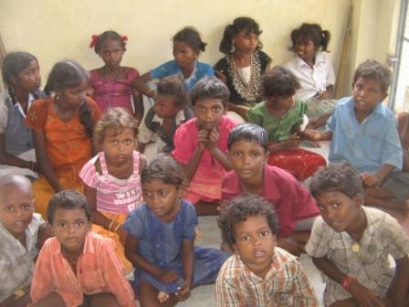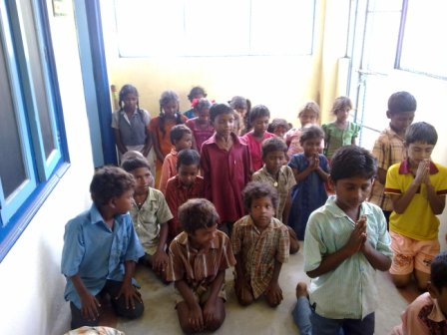
Yanadi Children at House of Restoration

Since we started working with Yanadi community our God had brought many changes in their lives. Children who used to beg in the streets are now going to schools. Almost 70% of this people stopped drinking alcohol. Many families have thrown away the images and pictures of false god’s and many families invited Jesus to their families! Praise the Lord!! Halleluyah!!
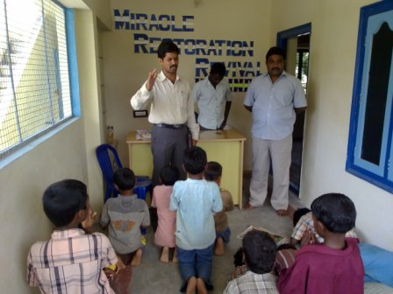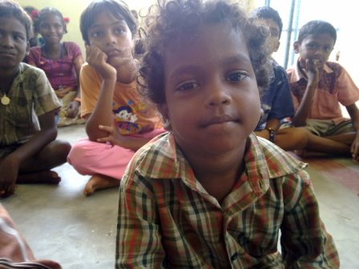
Pastor Anil praying for the kids

Thank you Lord Jesus for using us to work with these people! We feel happy when we think about their past situation and present situation. We are praying to the Lord for a100% change in the Yanadi community and see all of them accept Jesus Christ as Savior. It brings joy and happiness to each of us right from children to pastors to work with the Yanadi’s.The children in House of Restoration treat the Yanadi children as their own brothers and sisters. During our food feeding program, it is our children of H.O.R. who do the entire work like serving the food, teaching them prayers, the word of God, play with them etc. The Yanadi children feel very happy playing with our Kids in H.O.R. They all cry when leaving.

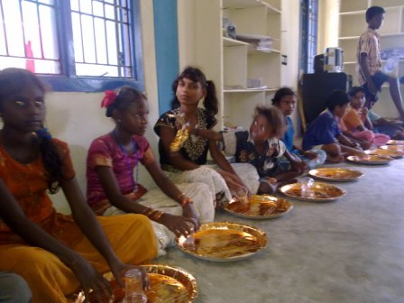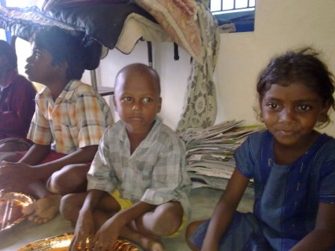
Yanadi Children ready to eat food

We thank Lord for each and every one of you who have been led by the Lord in supporting the works of MRR India. With your love and prayers we will do many more works for our Lord and lead many people to Jesus Christ. We are praying Lord to reach the Yanadis with many more works like arrange a medical camp right in the Yanadi locality, educate them to live in a right way in the society etc. We request each one of you to pray for this community in your daily prayers, that one day we can see this ENTIRE community live for Jesus Christ.

Thanking You

In Jesus Christ’s Service

Anil Palepu
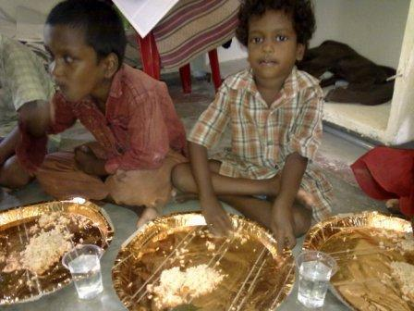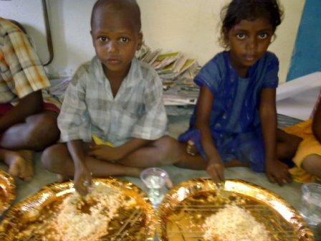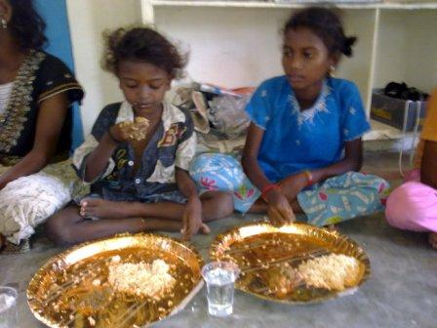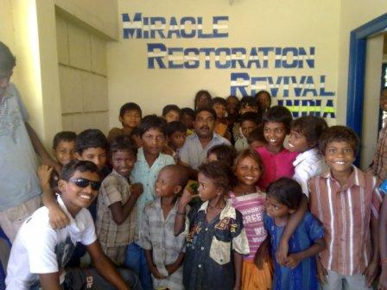

HALLELUYAH

